Algebra 1: Unit 13, Lesson 1

- Raine invested $\$3,600$ into a $13$-year certificate of deposit (CD). To monitor her money, Raine graphed the equation that models her investment.
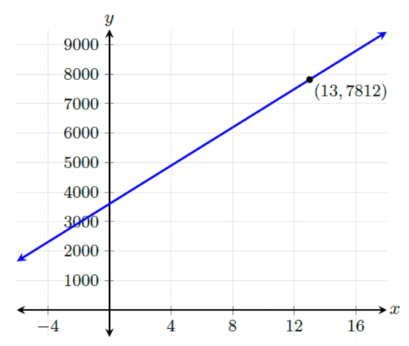
What does the $y$-value of the coordinate, $(13,7812)$ represent?
The total amount of the CD after the fixed term.

- The equation, $A=150(1+0.15t)$, can be used to determine the final amount, $A$, in a savings account at a neighborhood bank after $t$ years.
What is the original amount?
$$\$150$$

- The graph of the equation $A=1500(1+0.21t)$, where $A$ is the final amount in a certificate of deposit (CD), $t$ years after the account was opened, is shown.
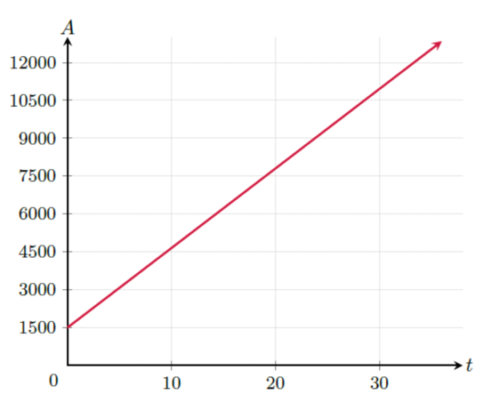
After how many years will the value of the CD be at least $\$4,500$?
$10$ years

